**Modules, require() and NPM**

Using modules in your application

▪Three most common sources of Node modules

# Using modules in your application

**Using modules in your application**

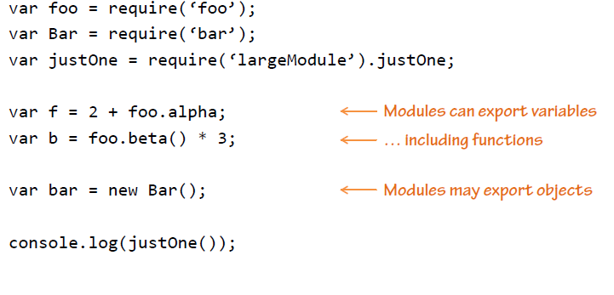

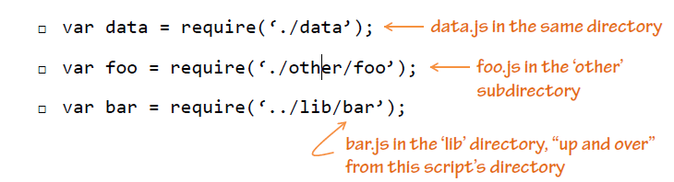

# ▪Three most common sources of Node modules



